Case 18-AM,C-Taino-Celt-Serpentine-Type 1 Elongated Base-Fewkes

This extraordinary work of art came from the Dominican Republic. carved in serpentine stone. Many details  8''3/4 long, 4''1/4 height  and 3''1/8 base. weight 6 pounds.

please note: This item has been broken in the base, and was glued back together and has some scratches.

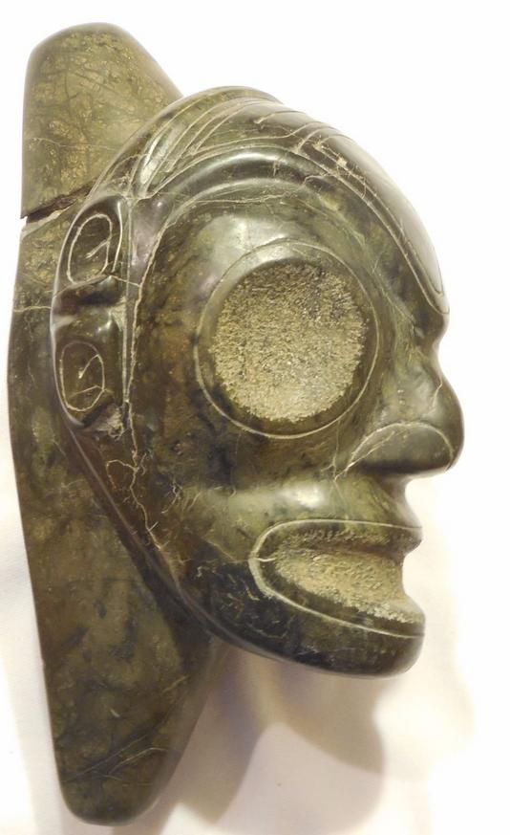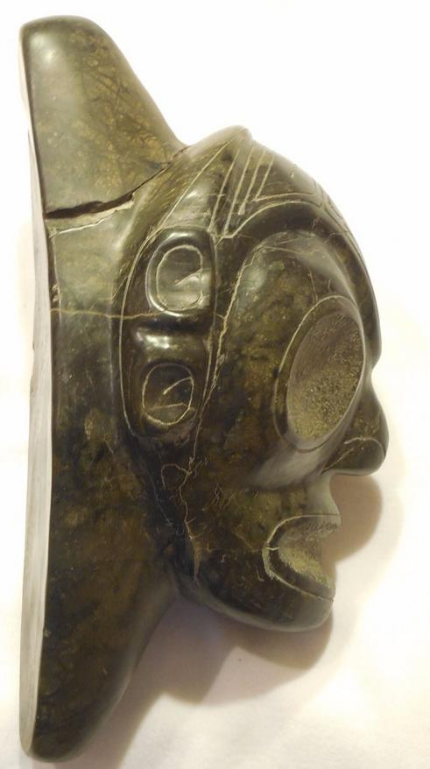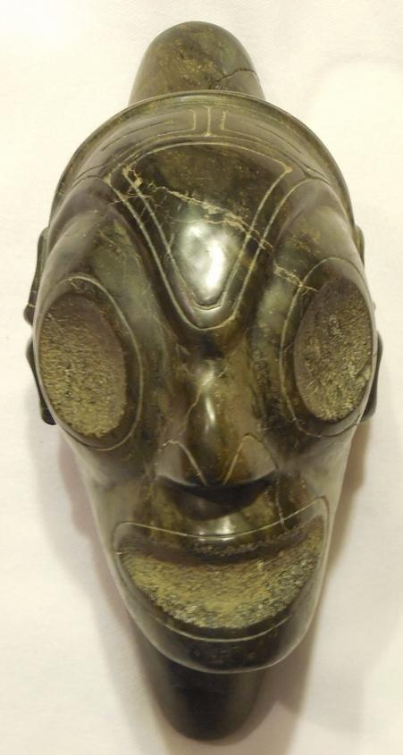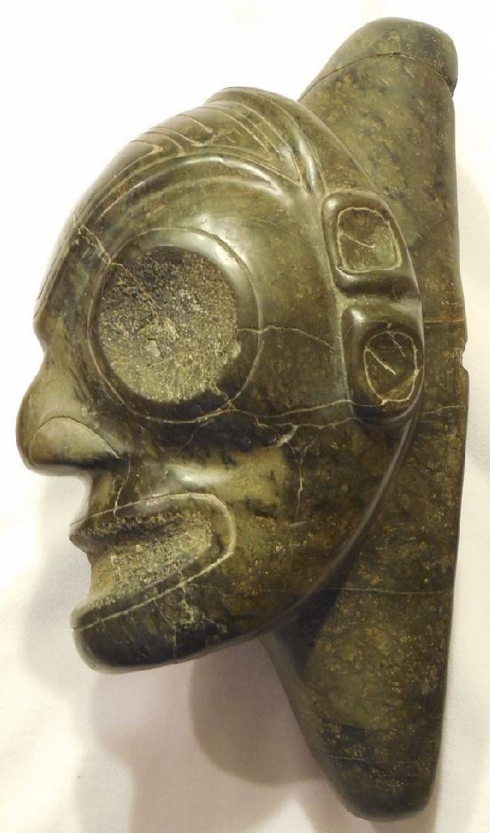

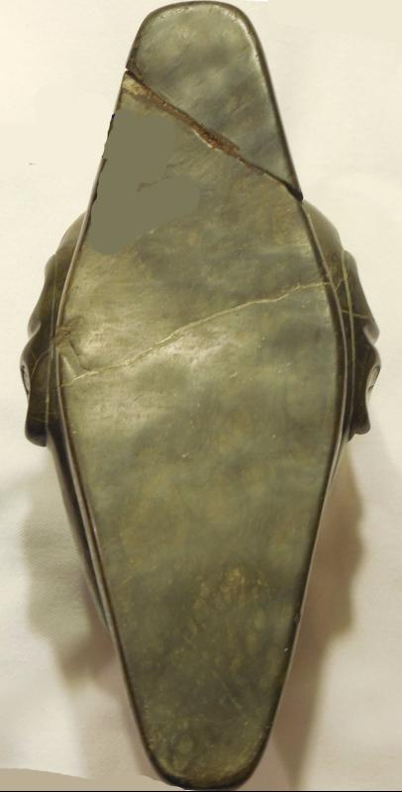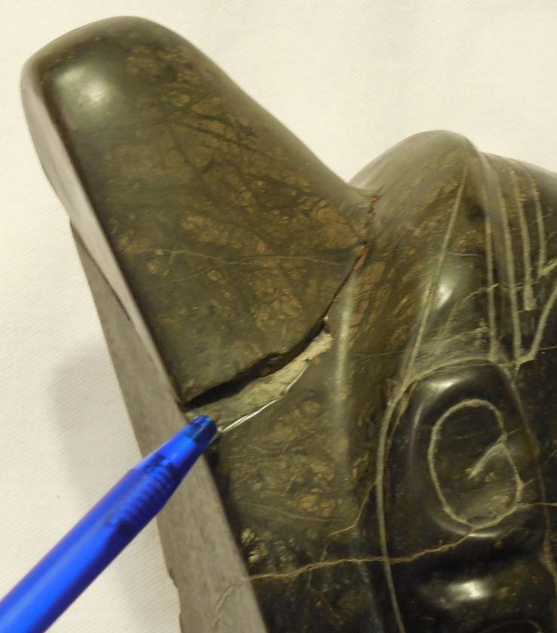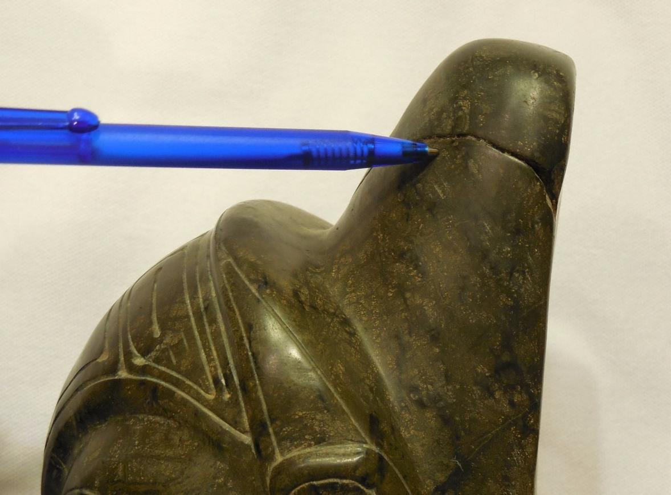

# Order details

## Sales order

Sold by [jeanpier_360](http://myworld.ebay.com/jeanpier_360) ( [95](http://feedback.ebay.com/ws/eBayISAPI.dll?ViewFeedback&userid=jeanpier_360) )

### Delivery package 1 of 1

Estimated delivery Saturday, Jan 16, 2016

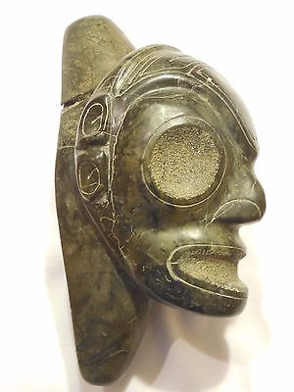

#### [TAINO PRE-COLUMBIAN STONE HEAD](http://www.ebay.com/itm/262221566039)

|  |  |
| --- | --- |
| Item price | $175.00 |
| Quantity | 1 |
| Item number | 262221566039 |
| Shipping service | USPS Priority Mail Medium Flat Rate Box |

## Shipping address

Ralph J Coffman Jr

149 Atlantic Ave

Swampscott MA 01907-2427

United States

## Order total

|  |  |
| --- | --- |
| Subtotal | $175.00 |
| Shipping | $12.00 |

**Total**

$187.00